|  |
| --- |
| **EXP-02 Comparative Analysis of Naïve Prompting versus Basic**  **DATE Prompting Across Various Test Scenarios** |

Jijendra Prasaath S B - 212221030015

**Aim:** To test and compare how different models respond to naïve prompts (broad or unstructured) versus basic prompts (clearer and more refined) across multiple scenarios. Analyze the quality, accuracy, and depth of the generated responses.

**Procedure:**

1. **Objective:**
   * This analysis seeks to evaluate the responses of various AI models to different levels of prompt clarity. By comparing naïve (broad, unstructured) prompts to basic (clearer, more refined) prompts, we aim to understand how prompt precision influences the quality, accuracy, and relevance of AI-generated responses.
   * Recognizing how prompt specificity impacts AI responses is essential for users seeking optimal model performance across various tasks, including factual responses, creative output, and technical explanations.
2. **Background:**
   * **Naïve Prompts:** These prompts are typically broad, lack specific context, and offer little guidance to the model on the desired depth or focus. For example, “Tell me about climate change” leaves the model guessing about the expected detail level, focus (causes, effects, solutions), and tone (formal, conversational).
   * **Basic Prompts:** Basic prompts are clearer and provide essential context, giving the model specific direction on desired content. For example, “Provide a brief overview of climate change, covering its causes, major impacts, and potential solutions” offers a structured focus that the model can directly follow.
   * **Evaluation Metrics:** Key metrics for assessment include quality (how well the response addresses the prompt), accuracy (factual correctness), depth (level of detail), relevance (response alignment with prompt), conciseness, and adaptability (the model's ability to infer missing context or handle vague requests).

**Methodology**

1. **Models Selection**:
   * Selected models include GPT-3.5, GPT-4, Claude, and a leading open-source model. These choices reflect a range of capabilities: GPT-4 for depth and contextual handling, Claude for precision and conversational tone, and an open-source model to assess adaptability with less refined prompt engineering.
2. **Prompt Scenarios**:
   * Five core scenarios were chosen: summarization (e.g., summarizing an article), complex query answering (e.g., explaining a scientific concept), creative writing (e.g., storytelling), technical explanation (e.g., explaining a code snippet), and opinion-based inquiry (e.g., pros and cons of remote work).
   * Each scenario was tested with a naïve prompt (e.g., “Explain photosynthesis”) and a basic prompt (e.g., “Describe the photosynthesis process, highlighting the roles of chlorophyll, sunlight, water, and carbon dioxide”).
3. **Evaluation Metrics**:
   * Responses were assessed on a 5-point scale across each metric: quality, accuracy, depth, relevance, conciseness, and adaptability. Qualitative notes complemented scores to capture nuances in model behaviour.

**Analysis of Naïve Prompts**

1. **Scenario Results:**
   * Across scenarios, models generally struggled to deliver high-quality, focused responses to naïve prompts. For instance, the prompt “Explain climate change” yielded overly general responses that varied significantly in depth, with GPT-4 providing the longest response but often including assumed context. GPT-3.5 produced more concise but sometimes oversimplified answers, while Claude gave balanced, conversational responses. Open-source models tended to lack depth and occasionally delivered irrelevant information.
2. **Observations:**
   * **Strengths**: Even with naïve prompts, most models maintained coherent structure and basic accuracy. GPT-4 demonstrated the ability to generate detailed responses and occasionally inferred missing context.
   * **Weaknesses**: Naïve prompts led to frequent misalignment with user expectations. Open-source models struggled with specificity, while GPT-3.5 and Claude often missed certain details. Depth and relevancy suffered most, as models guessed at the focus or omitted critical aspects due to insufficient guidance.
   * **Variability**: Model responses varied significantly in length and complexity. For instance, creative writing prompts led to simple, shorter responses from most models except GPT-4, which created more complex narratives.

**Analysis of Basic Prompts**

1. **Scenario Results:**
   * With basic prompts, models delivered more targeted, structured responses. For example, when asked, “Explain photosynthesis by focusing on chlorophyll and energy transformation,” GPT-4 produced an in-depth answer that maintained focus, while Claude generated a succinct, clear explanation. Even open-source models improved, delivering responses more aligned with the prompt’s requirements.
2. **Observations**:
   * **Improvements**: Basic prompts markedly enhanced depth, accuracy, and alignment with the intended focus. Responses were consistently higher quality and demonstrated better adherence to the prompt structure.
   * **Model-Specific Benefits**: GPT-4 showcased the most substantial improvement in depth and relevance, effectively addressing all prompt components. Claude exhibited clear, concise answers suitable for simpler explanations. Open-source models showed marginal improvement, though remained less accurate than proprietary models.
   * **Detailed Comparison**: With refined prompts, GPT-4 generated responses of greater depth and accuracy, while GPT-3.5 offered quicker, more concise responses that suited straightforward tasks. Claude’s responses were consistently accurate but leaned towards conversational summaries, suitable for non-specialist audiences.

**Key Findings and Insights**

1. **Prompt Sensitivity**:
   * GPT-4 demonstrated high sensitivity to prompt clarity, delivering accurate and in-depth responses when given basic prompts. Claude also benefited, offering clearer explanations with basic prompts but struggling with inferential depth on naïve prompts. Open-source models were less responsive to prompt refinement, suggesting limitations in inference capabilities.
2. **Efficiency and Practicality**:
   * Refining prompts proved especially practical for tasks requiring depth and specificity, as it reduced the time needed to clarify responses. GPT-3.5 and Claude consistently provided efficient, relevant answers with concise prompts, beneficial in time-sensitive scenarios.
3. **Contextual Adaptability**:
   * While GPT-4 adapted to inferred context best, it also occasionally over-explained on naïve prompts. Claude’s adaptability shone in conversational and practical summaries but lacked depth on more technical prompts. Open-source models were the least adaptable, suggesting a need for more explicit guidance.
4. **Summative Comparison Table**:

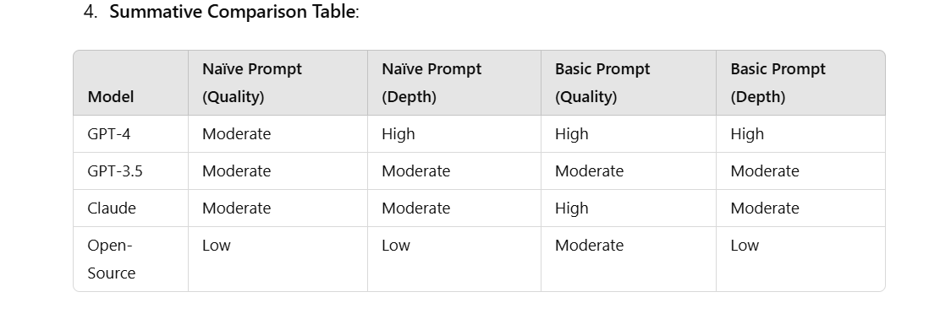

**Conclusion and Recommendations**

1. **Summary of Findings:**
   * Prompt clarity significantly impacts response quality across AI models, with GPT-4 showing the most noticeable improvement in depth and relevance. While all models improved with basic prompts, open-source models exhibited the least benefit from prompt refinement.
2. **Best Practices**:
   * For optimal results, users should provide clear, structured prompts, detailing scope and focus to guide models more effectively. This ensures higher accuracy and alignment with user intent, particularly for complex or nuanced queries.
3. **Future Directions**:
   * Advancements in prompt interpretation and model adaptability could reduce reliance on highly structured prompts. Future research may explore models’ abilities to interpret unstructured, nuanced prompts across specialized fields or to employ adaptive contextual inference, further enhancing usability across diverse applications.